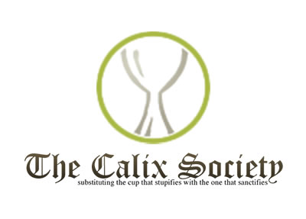
A Warm Invite From Calix
Calix is a worldwide organisation open to those who are maintaining their sobriety through participation in their Catholic faith and a 12 step program. It is certainly not a 'Catholic AA' and encourages members to also be involved with the 12 step program through AA.
The Calix meetings involve prayer, personal sharing and reflection and are confidential. Membership is also open to non-Catholics and to anyone with experience of and a concern for the effects of alcoholism in people’s lives.
A Calix Group has been meeting in the Diocese of Hallam for over twenty years. Prior to Covid the meetings took place every second and last Monday evening at the Holden Hall by the side of St Marie's Cathedral. The meetings have continued during Covid on Zoom and a group app has been introduced giving further help and support.
The Calix Group in Hallam is now introducing another opportunity to meet on Zoom. It will be every first Wednesday of the month at 1-30 in the afternoon and ending by 2-30. This service begins on the 2nd Dec and it is hoped that the Wednesday meetings will appeal to those who are unable to join us on a Monday evening.
If you would like to learn more about our meetings please contact Fr Desmond Sexton on 01709 363753 or desmond.57@btinternet.com

In the meantime keep safe and God Bless you.

