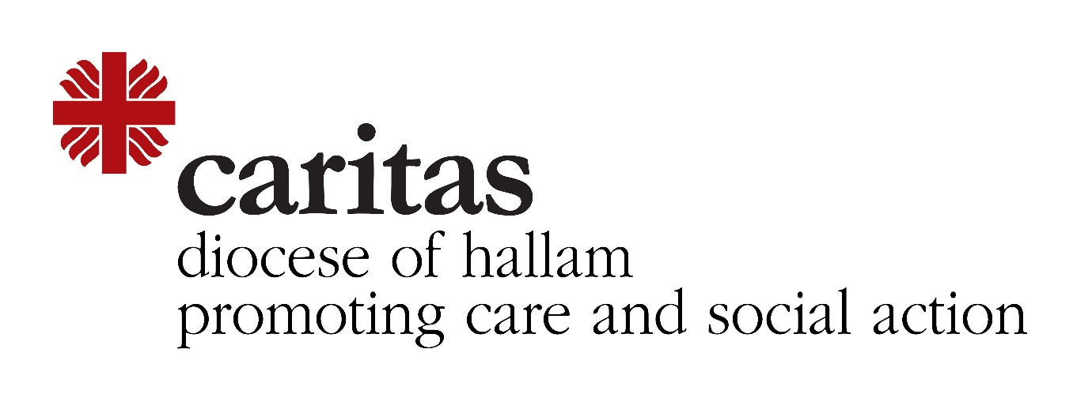Deaf Ministry
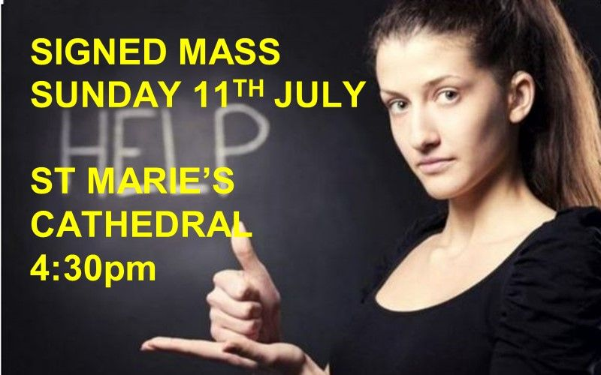

Celebrant: Fr Jim Clarke
No booking needed - stewards will ensure social distancing

