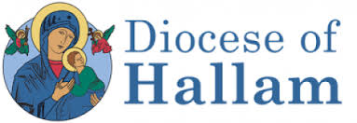
Director of Youth Ministry

£30,000 to £35,000 dependent on experience

35 hours a week, permanent
To commence as soon as possible

The Diocese of Hallam comprises of 54 parishes and 47 schools in South Yorkshire and parts of Derbyshire and Nottinghamshire.

The Diocese is looking to recruit an experienced, dynamic and forward-thinking individual to the role of Director of Youth Ministry. You will lead on the development and implementation of a three-year plan and build, sustain and lead the ethos, vision and mission of Youth Ministry within the Diocese.

Previous significant experience of working with young people is essential, together with a passion for youth evangelisation. The successful candidate will work in partnership with priests, parishioners, school chaplains, volunteers, and the Young Adults Ministry team at St Vincent’s Mission Hub, which is where their office will be based.

There is a Genuine Occupational Requirement for the postholder to be a practising Catholic. The successful candidate will be required to apply for an Enhanced DBS check prior to taking up their post. The role will involve some evening and weekend working.

Interviews will be held, in Sheffield, on Friday 15th October and are expected to last a full day.

An application pack can be obtained from Mrs Jessica Moylan – jmoylan@hallam-diocese.com

Closing date: Noon on Wednesday 6th October 2021

Diocese of Hallam – Flame 2019

