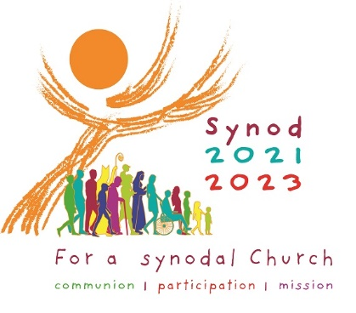 | An Invitation  Pope Francis has asked all the members of the Church throughout the whole world to get involved in the next Synod. The word synod simply means “walking together” In the diocese of Hallam we plan to begin our journeying in prayer. Bishop Ralph would like to invite you to join people from all over the diocese in a Liturgy at St Marie’s Cathedral at 4:30 pm on 17 October 2021. This will hopefully be live-streamed on the Cathedral website so that anyone can join in this time of prayer. Even if you cannot be there please remember to pray that all of us may be open to the guidance of the Holy Spirit.  Further information from synod@hallam-diocese.com

Synod Working Group
Every parish in the diocese has been invited to nominate two representatives to join the Synod Working Group. If you would like to volunteer in this role please speak to your parish priest. The first meeting will take place over Zoom on 22 October 2021 at 7:00 pm. Make sure that your details are returned before 17 October so that you get the invitation to the meeting.
Further information from synod@hallam-diocese.com

