Safeguarding Training for Parish Volunteers
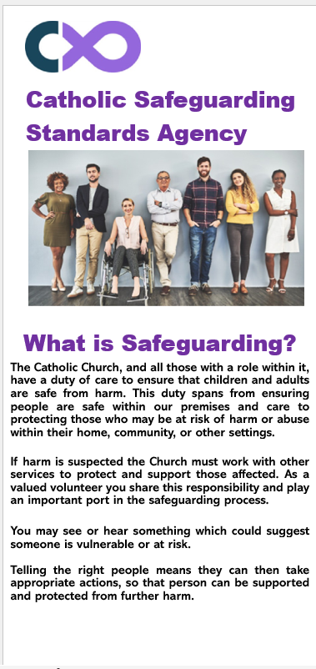
Level 1 Beginners (2 page leaflet)
This has been designed for those who are volunteering in the parish but do not have any involvement with children, young people or vulnerable adults and a DBS check is not required for their role. For e.g.
Readers
Welcomers
Flower Arrangers
Tea/Coffee or Lunch Club
Cleaners

The leaflet can be taken away to read (copies can be obtained from Jo at the safeguarding office) or volunteers can download it directly from the CSSA learning portal website and save electronically. The portal can be accessed
by signing up via: https://training.catholicsafeguarding.org.uk/

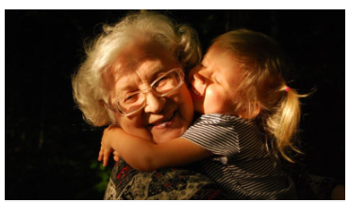

Level 2 Intermediate (Online module) Certificate

This module is the standard mandatory requirement for volunteers who have an active role with children, young people or vulnerable adults for which a DBS check is required. For e.g.

Children’s Liturgy (Leaders and Helpers)
Catechists
Altar Servers (over 18s only and only applicable if children serve
alongside adult servers.
Parish Visiting Groups /Eucharistic Ministers (home visiting duties only)

The module must be completed before commencing in role (new volunteers) or whilst a DBS renewal is being processed (existing volunteers). The training is renewed in line with the DBS check (every 3 years).

Anyone can complete the Level 2 training if they wish (even if they do not hold a DBS eligible role), by signing up to the portal. A Certificate of Attendance will be issued on completion of the module.

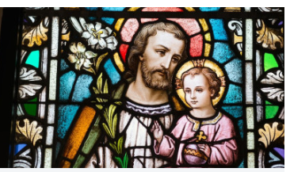
Level 3 Advanced (Online Module) Certificate

This module is the standard mandatory requirement for volunteers who have direct safeguarding responsibilities for which a DBS check is required. For e.g.

Parish Safeguarding Reps
Diocesan Counsellors
Members of Clergy from overseas (on their arrival into the Diocese)
A Certificate of Attendance will be issued on completion of the module.

