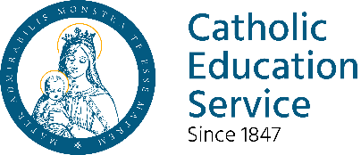
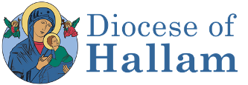

Course Programme
Module One: The Bible I
What is the Old Testament?
Images of God
Exodus Event
The Experience of Exile

Module Two: The Bible II
What’s in the New Testament?
The Easter Event
What is a Gospel?
A Look at New Testament Letters
Using the New Testament Today

Module Three: Jesus Christ
Images of Jesus
Jesus, Human and Divine
The Teaching of Jesus
The Saving Work of Jesus
The Cosmic Christ

Module Four: The Church
Images of the Church
The Church in Our Times
The Mission of the Church
Ecumenism & Other Faiths

Module Five: Sacraments
Signs and Symbols
The Church as Sacrament
Baptism, Confirmation, Eucharist

Module Six: Morality
Foundations of Christian Morality
Making Moral Decisions
Human Life
Peace and Justice

Module Seven & Eight:
Specialist Choices
Catholic Certificate in Religious Studies (CCRS)
Register now for September 2026
What is the CCRS?
This is a certificate course validated by the Bishops’ Conference of England and Wales. It offers a basic foundation in Catholic theology and practice through teaching, discussion, study, and personal reflection.
Who is it for?
Anyone who wants to undertake some serious, but accessible, study into Catholic theology. It is particularly well-suited for staff in Catholic schools, parish catechists and those involved in various aspects of lay ministry.
What does it cover?
The six core modules cover:-
- Bible I (The Old Testament)
- Bible II (The New Testament)
- Jesus Christ
- The Church
- The Sacraments
- Christian Morality

Specialist modules currently offered in Hallam include:

- Catholic Religious Education
- Liturgy
- Catholic Social Teaching

What work is required?
If you wish to obtain the Certificate you need to complete a piece of work for each module (usually 1500 words) and attend three sessions for each module. You can come along to the sessions as an “auditor”, just to take part, if you do not wish to work for the Certificate. Most people, however, find that the written work helps them understand and find out more.

What happens if I cannot complete the course?
CCRS - KEY FACTS
6 Core modules, plus 2 specialist modules
Each module includes 10 hours teaching time
Taken over 2 years or more
Costs £60 (£30 for low-income) per module plus £20 Registration
Examines core themes of Catholic faith and theology
Excellent formation for catechists, pastoral workers and anyone interested in deepening their understanding of Catholic faith
Supports professional development for teaching in Catholic schools
Awarded by the Board of Religious Studies on behalf of the Catholic Bishops’ Conference of England and Wales
Delivered locally by a team of theologically qualified tutors

Course Programme
Module One: The Bible I
What is the Old Testament?
Images of God
Exodus Event
The Experience of Exile

Module Two: The Bible II
What’s in the New Testament?
The Easter Event
What is a Gospel?
A Look at New Testament Letters
Using the New Testament Today

Module Three: Jesus Christ
Images of Jesus
Jesus, Human and Divine
The Teaching of Jesus
The Saving Work of Jesus
The Cosmic Christ

Module Four: The Church
Images of the Church
The Church in Our Times
The Mission of the Church
Ecumenism & Other Faiths
Module Five: Sacraments
Signs and Symbols
The Church as Sacrament
Baptism, Confirmation, Eucharist
Module Six: Morality
Foundations of Christian Morality
Making Moral Decisions
Human Life
Peace and Justice
Module Seven & Eight: Specialist Choices

The CCRS is fully “portable”. If you move or cannot complete the course in this diocese, you can take the modules you have completed with you and finish the course in another. Or you can take time out and pick up modules later. You have five years to complete the programme.
How much will it cost?
There is a £20 national registration fee. Each module costs £60, which includes all tuition, worksheets and marking of assignments. For anyone on low income, the cost is £30 per module.
Where and when will it happen?
The course is delivered with a blend of online and in person delivery held at the Hallam Pastoral Centre in Sheffield on Saturday mornings, over a period of two years (12 Saturdays per year). Tea and coffee provided.
I’ve got questions…
Good! Questions and discussion are encouraged on the course. If you have queries about whether the course is for you, please contact Kevan Grady: kgrady@hallam-diocese.com

More information is also available on the national CCRS website:
https://www.catholiceducation.org.uk/ccrs/course
CCRS Programme 2026-27
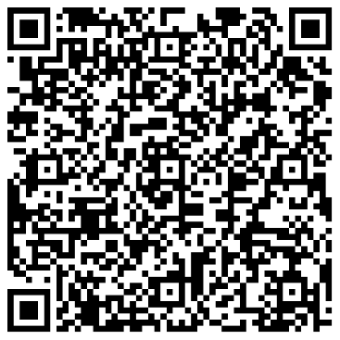
Register using this QR Code
 | Year 1 Students | Dates
Unit 1 | Old Testament
  26/09/26
  10/10/26
  17/10/26
Unit 2 | New Testament
  14/11/26
  28/11/26
  5/12/26
Unit 3 | Jesus Christ
  06/02/27
  06/03/27
  13/03/27
Unit 4 | The Church
  24/04/27
  08/05/27
  15/05/27

