Dear Father,

The Catholic Certificate in Religious Studies (CCRS) will be delivered once again in the diocese starting in late September. I would be grateful if you would include the attached item in your parish newsletter and, if possible, display the attached poster. I would also appreciate it if you bring it to the attention of any catechists or others who might be interested in it, share the attached factsheet with them, and encourage them to complete the registration form.

https://docs.google.com/forms/d/e/1FAIpQLScnHXESPxZHcgQ3JuiO1ECObEyZMFjZIKMJtIEjwwb1VI-VxQ/viewform?usp=header
If you require any further information, please do not hesitate to contact me.

Yours sincerely,

Kevan Grady

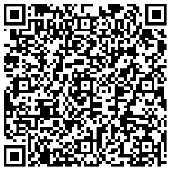  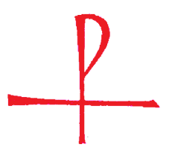 | Calling all Catechists and others who would like to deepen their faith  The Catholic Certificate in Religious Studies (CCRS) will be delivered in the diocese starting in late September. This certificate course is validated by the Bishops’ Conference of England and Wales. It offers a basic foundation in Catholic theology and practice through teaching, discussion, study, and personal reflection. If you are interested in joining the course this September, then please complete the registration form using the link or QR code. https://docs.google.com/forms/d/e/1FAIpQLScnHXESPxZHcgQ3JuiO1ECObEyZMFjZIKMJtIEjwwb1VI-VxQ/viewform?usp=header  For more information contact: formation-mission@hallam-diocese.com  Tel 0114 256 6410

